CIS 634 Object Oriented Software Engineering Course Project

TICKETING TOOL GROUP – 4

Test Specifications of Ticketing Tool Project

INTRODUCTION

This is simply a documentation of the software test plan for the ticket issuing system for an organization. The project goal and main objective for this system is to provide the automated ticket selling for public uses. The document will therefore cover in detail, the information about testing plan and test cases used for this project.
The target audience for this project is for public use, however, managed and run by any organization that buys and owns it. We will utilize test criterions under several testing methods consisting of white box, black box and system testing paradigm which comprises stress testing, and other testing practices.

Goals and Objectives

The main objectives are as follows:

Provision of 24-hour service - The system is expected to provide a service that lasts about 24 hours. Capable of providing service without stopping and going off.
Provision of selling tickets to clients - The system is expected to have the tickets sold in a concise and in a manageable way.
Provision of event creation and management - Events are created in the system and, should be capable of managing the events created.
Provision of report management - Capable of report management. Able to create reports in respect to tickets, events, clients registered, so on and so forth.

Statement of Scope
This part consists of scope of work the system will be able to handle and the product description and the requirements needed to set up the system as well as build it.

The scope of the project is as follows:
Developing a suitable ticketing system is part of the scope.
Event management is and will be part of the scope. Creating events, as well as managing created events.
Ticket selling and issuance will be part of the scope. Authentication of the users to the system is part of the scope.

Out of scope:
Settings management and authentication permission issuance is out of scope.
Development and Management of the team plan is out of scope. Management of financial plan and budget allocation is out of scope.

Test Plan
In our testing process, we will be applying the same test specifications that are well described in the IEEE Standard 829 software testing documentation. Several test strategies will be used including the tech stack as well as environment, and tools to use while testing.
We will as well look at the test plan timetable which lists all the activities that should take in the testing process, that is, in respect to time. The test

plan simply aligns the schedule of the testing process to make sure good quality assurance is met.

Software to be tested

The software here to be tested simply consists of what and where to be tested in the ticketing tool system. The exclusivity on testing comprises those tests which are not yet fully implemented and hence requires more time to implement, and merge changes.

The test inclusions are as follows:
    - Authentication of the users will be managed.
    - Event creation in the system will be tested.
    - Management of the events will be tested.
    - Ticket selling and issuance will be tested.
    - Ticket status and creation of tickets will be tested.
    - Settings for the system will be tested.
    - The test exclusions are as follows:
    - High workloads on the server will not be tested.
    - Debit and Credit Cards will not be tested.
    - Network congestion and display will not be tested.
    - SMS and Several API Gateways will not be tested.

Testing Tools and Test Environment

The environment setup needed is such of an office. Why? This is because much of the needs are kind of office tools. Testing tools are simply the tools needed in the process of testing of the system. The system being internet based, we can test it anywhere and everywhere one resides. However, some requirements are needed to have before making a step of testing this software.

The tools must comprise of the following:
    - One Network Controller
    - Three network PC’s, With Main Known Operating system, Windows, Mac, Linux.
    - Oracle or Microsoft MySQL server.
    - RAM: 2 GB RAM or above
    - Hard Disk: 20 GB hard disk or above.
    - Integrated Development Environment – Visual Studio Code.
    - Several Known Browsers - Main Browser to have will be Chrome, Firefox, and Safari browser.

Test Schedule and Milestones:

This simply refers to the test plan of the project processes. Comprises a test plan aligned in respect to the predefined date for project development

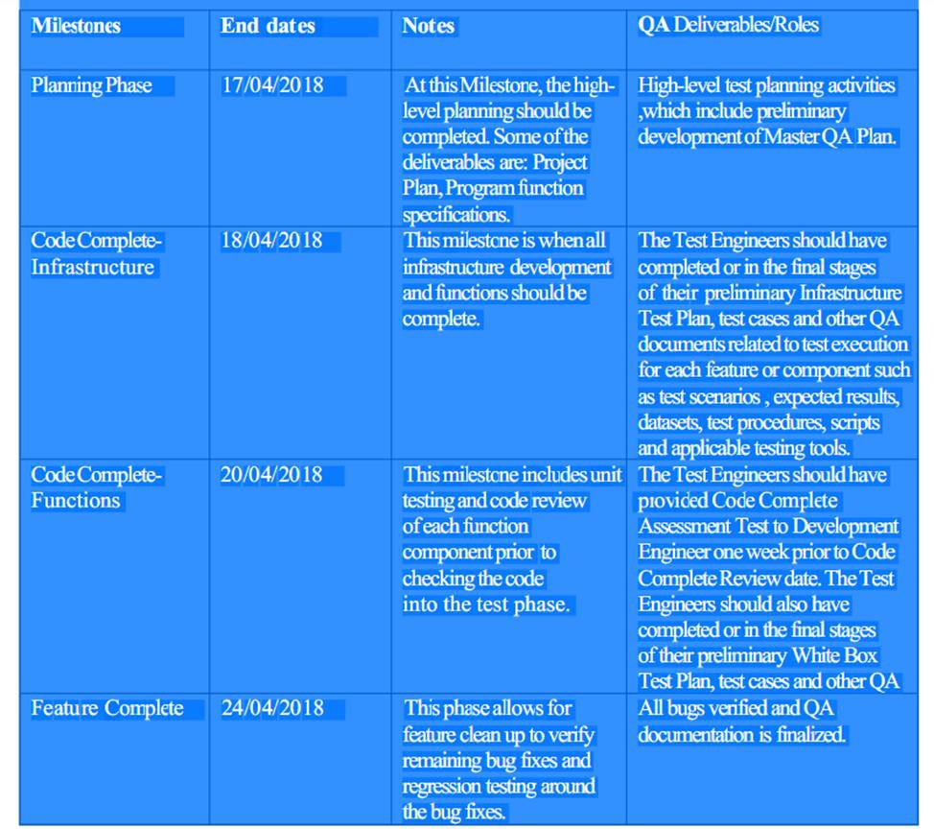

3.0 Test Cases
Test cases consist of test methods used to facilitate the project testing process. The methods were not limited to testing paradigms of the project.
We shall have the test case methods as follows:

ID | 1
Test Input | Register Module
Expected Output | Success on Registration
Description | This is a registration module, which records user information on the database. The information should be used to login to the system by the help of the login module. System Users trying to register, must have a unique identifiable registration number by the super admin for security purposes.

ID | 2
Test Input | Login Module
Expected Output | Log in the User to Dashboard.
Description | This module is expected to facilitate the login of users and access of one's own account. Makes Users authenticated to the system.

ID | 3
Test Input | Event Creation Module
Expected Output | Success in creation of events.
Description | This module facilitates creation of events. The events are to aid on ticket issuing and mapping the tickets on predefined events. The events are to be managed by the manage events module. The next version should have other modules implemented including the manage event module, where viewing, and other management tasks are done on the events created.

